Sunday | Monday | Tuesday | Wednesday | Thursday | Friday | Saturday
 |  |  |  | 1  All Fools’ Day | 2  Good Friday | 3
4  Easter Sunday | 5 | 6 | 7 | 8 | 9 | 10
11 | 12  Ramadan Begins | 13 | 14 | 15 | 16 | 17
18 | 19 | 20 | 21 | 22  Earth Day | 23 | 24
25 | 26 | 27 | 28 | 29 | 30  Arbor Day

Northland Heights Activity Calendar |  |  |  | 10:00: April Foolishness Funny Hat Parade Candid Camera + World’s Funniest Practical Jokes.  11:00: Would You Rather  Game? + This or That Game  2:00: April Fool’s Patio Social  6:00: Large Print Jokes | 10:00: Spring Poems  11:00: Meditation + Chair  Yoga – Gentle Stretching. Complete the Cliche’  2:00: Cross Craft  3:00: Spiritual Movie: Paul  Apostle of Christ  6:00: Heartwarming Stories | 10:00: Family Phone Calls  1:00: Retro T.V Series:  Gunsmoke + The Big Valley  2:00: Ice Cream Social = Reminisce – Easter Bonnets  Church Finery Growing up.  3:00: Card Player’s Choice  6:00: Saturday Matinee:  Wyatt Earp
Happy Easter  Have a Beautiful & Blessed…  Easter Day! | 10:00: Morning Stretch  Reminisce: Fishing Trips +  Pennsylvania Lake Areas  Fishing 101.  11:00: Go Fish!  2:00: Goldfish Social with  Mocktails - Cheers!  3:00: Nature Documentary  6:00: Adult Coloring / Art | 10:00: Farmer’s Almanac  Spring & Summer predictions  11:00 This Day in History +  Outdoor / Indoor Strolls  2:00: BINGO  Win wild surprises.  Greeting Cards for Pen Pals  3:00: Shut the Box Game  6:00: Sunshine Mazes | Pick Up A Penny Day  10:00: Penny Ante’  11:00: Penny Pitch - True or  False Facts – Give your 2 cents worth…  2:00: Nail & Hand Massage  Pastel Nail Colors for Spring  6:00: Too Cute on YouTube | Henry Mancini Day!  10:00: Finish the Song Lyric  11:00: Sit N Be Fit to Henry’s  Fabulous Show Tunes  2:00: Mancini’s Bread with  Jelly Tasting’s. YUM!  3:00: The Pink Panther Show  6:00 Air Hockey Shoot Out | Cherish an Antique Day!  10:00: Show N Tell – 1940’s …Bird Bud Vases!  11:00: Bird Watching in USA: Badminton Challenge  Optical Illusion Pages  2:00: BINGO + Ice Cream  6:00 HI – Low Cards | 10:00: Family Phone Calls  1:00: Dancing with the Stars  2:00: Ice Cream Social =  Reminisce – Are you a good  Dancer? Dancercise Moves  3:00: Card Player’s Choice  6:00: Saturday Matinee: Dance With Me – Starring  Vanessa Williams
10:00:  T.V. Mass  11:00:  Seated Exercise  1:00:  Fact or Fiction  4:00  BINGO | 10:00: Morning Stretch  & Famous Faces.  11:00: Chair Yoga  2:00: Muffin Tin Monday!  Baking: w/ Seasonal Berries  3:00: Muffin Social!  Recipes to Remember.  6:00: Large Print Humor page. | You are PEACHY Keen!  10:00: What is your Special  Talent? Yodel perhaps?  11:00: Morning Stretch  2:00 BINGO  Win fruity prizes!  3:00: Fruit Loop Toss  6:00: Colorful Abstract Art | A Day of Pink  10:00: Feeling in the pink…  Strolls and Rolls.  11:00: Mini Golf in a Pink  Paradise on the Patio.  Pink Wear PINK today!  2:00: Nail & Hand Massage  6:00: The Pink Panther  Movie clips | McDonald’s Anniversary  10:00: History of the Golden  Arches  11:00: Food Trivia  2:00: McDonald’s French Fry  Social – Retro Commercials  April Birthday Bash  6:00: Basketball | 10:00: Coffee and  Conversation: Good News  Stories  11:00: Chair Yoga  ART Quiz  2:00: BINGO + Ice Cream  International Art Month  6:00: UNO / Cards | 10:00: Family Phone Calls  1:00: Noodle Baseball  Baseball clips The Pirates  2:00: Ice Cream Social =  Baseball Slang Terms  3:00: Card Player’s Choice  6:00: Saturday Matinee:  Angels in the Outfield  Starring Danny Glover
10:00:  T.V. Mass  11:00:  Seated Exercise  1:00:  Fact or Fiction  4:00  BINGO | Mona Lisa Monday  10:00: DaVinci’s Artworks  11:00: Picture Day with  Props – Show Your Best Mona Lisa Smile.  2:00: Pasta Salad Recipe  Cooking Demo + Tastings  6:00: Board Games Palooza | 10:00: Daily Chronicles  Relaxing Wake up Videos  11:00: Balloon Volley  Fact or Fiction Game  It Happened in April…  2:00: BINGO  Come join us! Prize Bonanza  3:00: Name 10  6:00: Word Scrambles | 10:00: Jenga & Domino’s  Travelogue: Niagara Falls  History of Barrel Riders…  11:00: Ribbon Circle Moves  Musical Memories of the 60’s  2:00: Nail & Hand Massage  Pop Music Culture of Europe  6:00: Picture I.D. Waterways | Only Mother Nature Knows  10:00: Salt of the Earth  Travelogue – YouTube  11:00: Tai Chi Movement  2:00: Match Game  3:00: Soccer Shoot Out  World Cup Championship  6:00: Save Our Planet Facts | 10:00: Coffee and  Conversation: Good News  Stories  11:00: Chair Yoga  Password Game  2:00: EVENT ENTERTAINMENT: TO BE  ANNOUNCED…  6:00: Poker / UNO Cards | 10:00: Family Phone Calls  1:00: Wheel of Fortune  Game  2:00: Ice Cream Social  3:00: Card Player’s Choice  6:00: Saturday Matinee:  Batteries Not Included  Starring Jessica Tandy
10:00:  T.V. Mass  11:00:  Seated Exercise  1:00:  Fact or Fiction  4:00  BINGO | Ribbit, Ribbit Day  10:00: Frog Month – Strange  Facts about Frogs – Take a  Frog Personality Test.  11:00: Frog Toss  2:00 Green Froggy Parfait so leap into the luscious creation to eat!  3:00 Froggy Art  6:00: | 10:00: Daily Chronicles  11:00: Belly Dancing  Fact or Fiction Game  Word Ladder Game  2:00: BINGO  Come join us! Prize Bonanza  3:00: Famous Faces  6:00: Word Scrambles | 10:00: Jenga & Domino’s  Large Print Word Find  11:00: Ribbon Circle Moves  Musical Memories of the 60’s  Fun Facts  2:00: Nail & Hand Massage  How to Star Gaze at Night.  6:00: Picture I.D. Plants | Sports Day!  10:00: Table Golf  Noodle Baseball  11:00: Sports A-Z List It!  2:00: Target Shoot Out  Dog swims 10 miles to his home  3:00 Sport’s Bloopers  6:00History of Burg Sports | 10:00: Coffee and  Conversation: GARDEN  PLANNING + PLANTING  Flower Arranging  2:00: EVENT ENTERTAINMENT: TO BE  ANNOUNCED…  6:00: Gardening Books | Find your special joy participate & join new friends  Our Activity Room is open 24 hours a day – 7 days a week!  Let’s have some socially distant fun! There are wonderful games & materials in our Rec Room.
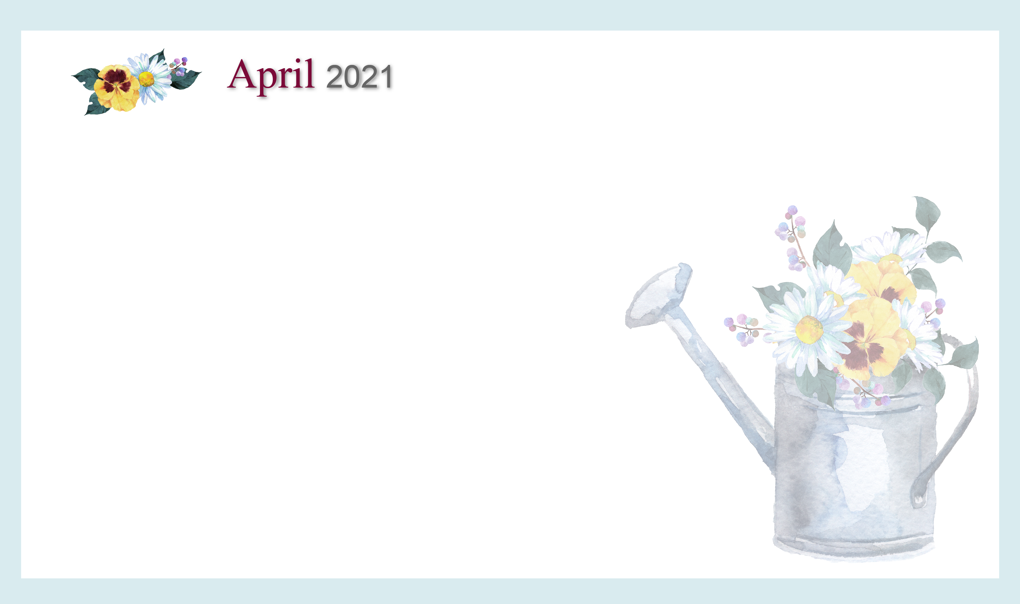
Debbie Scheer – Recreation Director – Northland Height’s Assisted Living: dscheer@northlandseniorliving.com –Please reach out to me anytime. It would be my pleasure to make your acquaintance!

